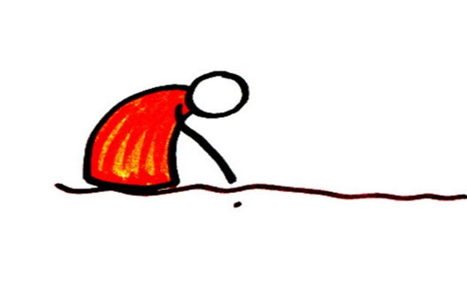  A farmer planted some tiny seeds in the ground and God sent the sun and the rain. | ~~~~~~~~~~~~~~~~~~~~~~~~~~~~~~~~~~  First grew little roots…… | ~~~~~~~~~~~~~~~~~~~~~~~~~~~~~~~~~~  then grew little shoots  with some leaves…….
~~~~~~~~~~~~~~~~~~~~~~~~~~~~~~~~~~  then the plants grew bigger… | ~~~~~~~~~~~~~~~~~~~~~~~~~~~~~~~~~~  …….and bigger until…. | 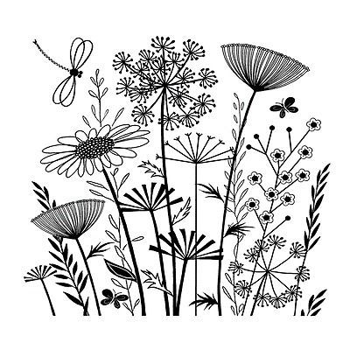  … there was a beautiful meadow of flowers, the birds, bees and butterflies came to sing and dance.

The little seeds
grew and grew…
just like God’s
love for ME

