ZOOM Children’s Activity July 25th
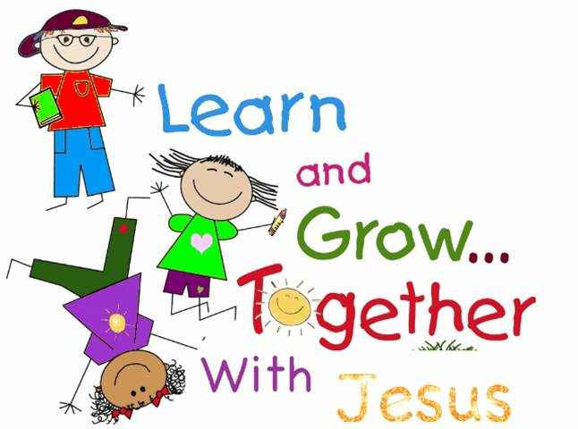
Hi again boys and girls,
Do you remember how last week Jesus was tired and hungry after speaking to so many people?
Well in our Bible story today we hear about 5,ooo people coming to see Jesus….that’s a HUGE number.
The people had sat and listened and now THEY were very hungry so Jesus asked if anyone had any food they could share and ONE LITTLE BOY came forward with his lunch of just 2 fish and 5 small loaves of bread.
Jesus then did something very special that we call
A MIRACLE.
Jesus’ friends, his disciples, shared out the 2 fish and 5 little loaves with the people, ALL 5,000 of them!
Afterwards there was even some left over.
ONLY Jesus can do such special things.
Your craft activities today include a colouring sheet to show the little boy with his lunch, a sheet where you can colour the loaves and fish, cut them out and put them into a basket with a lid, and a tricky colouring sheet to show how many baskets of food were left over.
I hope that you have fun with the crafts….enjoy!
Sue x

